So now we have all the setup complete, we are ready to go in and start looking at the program

Now everytime you start a blemnder you will get this splash screen as marked below

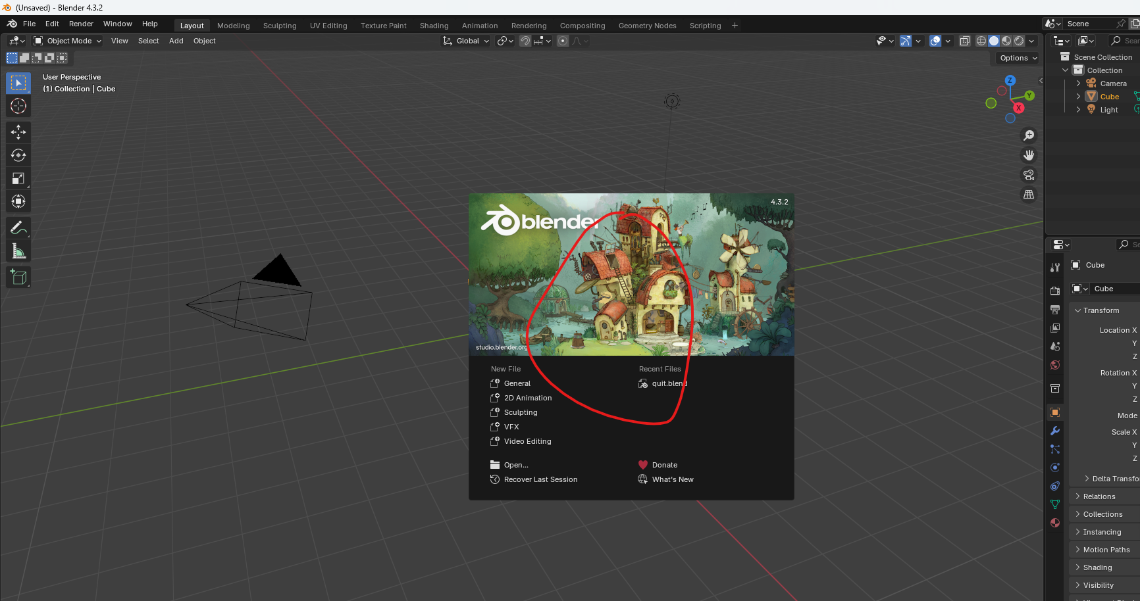

And if you have ever used Photoshop or something like that you will be familiar with this sort of start ( who know I think he I talking about the top window of every untitled project photoshop that shoes option of new project, open project )

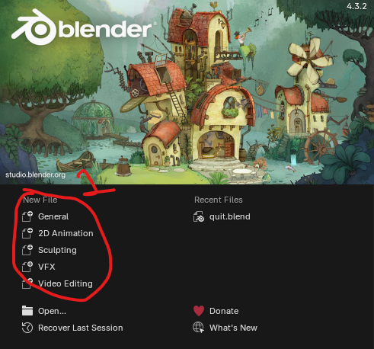

Now the left side is How you create a new file and the right side will have any recently opened files that you may have

You will have marked 1 for the template for the project that you want to create

Teacher always choose general because it will have every workspace the we need loaded into it by default ( maybe general is used for all the purposes and maybe workspace can be divided into many subtypes each serving a particular purpose ) and we will cover what workspaces are in just a moment here

0:35

So you can create a new file from some of these templates if you want to check them out or if you just click off the splash window

Bender already has a new general Blender file loaded up

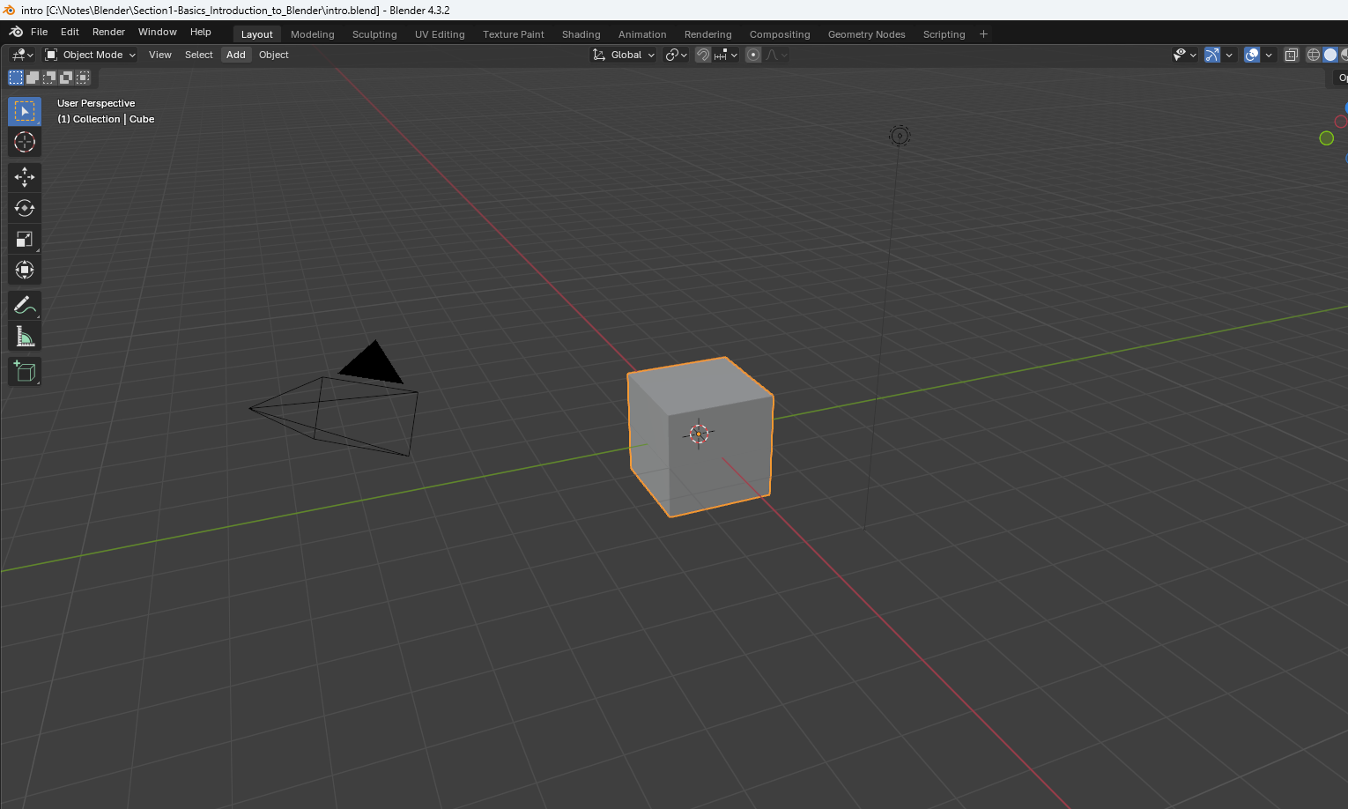

Now teacher knows that UI can be overwhelming if you are not used to it. Blender is a program that has lot of capabilities, so along with that comes sort of a busy screen.

We will not be using this right away. This is after all a basic course

Now teacher is going to go over this interface a bit quickly as an overview at first and we will comeback and revisits these things when they will be more relevant

This will be just to familiarize yourself with some of these menus and things truly understand what is happening on the screen

We actually need to know a little bit of math And don't be afraid.

Teacher is going to keep this all very high level concepts stuff.

So lets break down this thing little. It is a 3D modelling Software.

What does that mean

We all know that we perceive reality in the three dimension which means that any object in the universe universe can have its position be described mathematically using a set of coordinates using an X, Y and Z axis

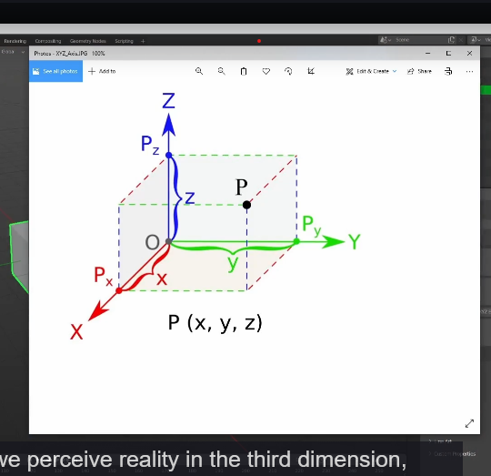

Blender X represents where the object is in the left and right direction

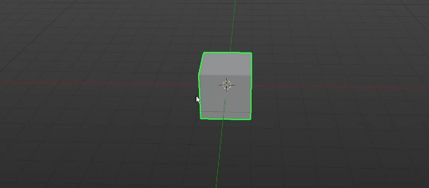

Y represents the forward and backward direction and z represents the up and down which we can see here drawn as the red, green and blue lines.

So what is 3d related to Computer graphics

The things we make in Blender, although they are 3d, they still need to be rendered or drawn onto a 2d screen in order for us to visualize it on the monitor here

So what a 3d modelling software does it give us the ability to create 3d objects that can be rendered onto a 2d screen in a way that allows us to perceive them as 3d by using the principle of perspective

Yes we are talking about the below

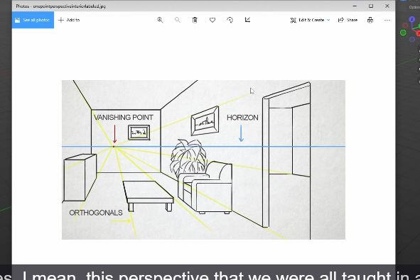

And yes, Teacher mean, this perspective that we were all taught in an opening art class, which teacher is not going to be covering in this, because this is a blender course, not an art fundamentals course.

There are tons of great free resources online.

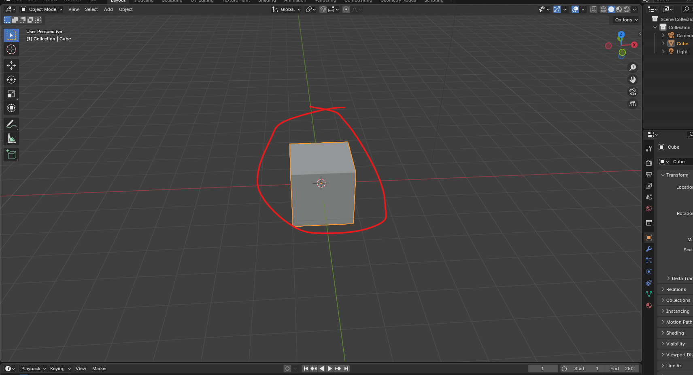

The marked view you are seeing is a 3d viewport which Is exactly what it is sounds like

It is a 3D view of the objects in our scene. The scene is simply how we describe the container for these objects and the space around it as represented. Y these grid lines

Here, the scene is essentially the blender file that we will create when we save this.

So Teacher may use the word scene and file here interchangeably. Every new Blender scene start with three objects in it that is a default Cube, a Camera and a light

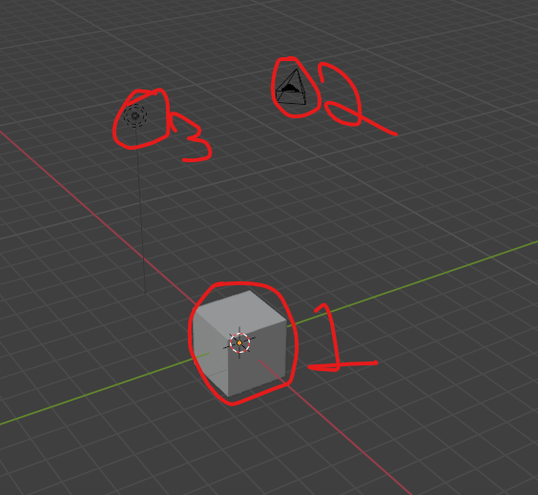

The marked 1 is cube and marked 2 is camera and marked 3 is light

We are going to get more into these objects types in future types in future lessons

Now there is a **popup panel** in the 3d viewport that you can access by hitting N on the keyboard

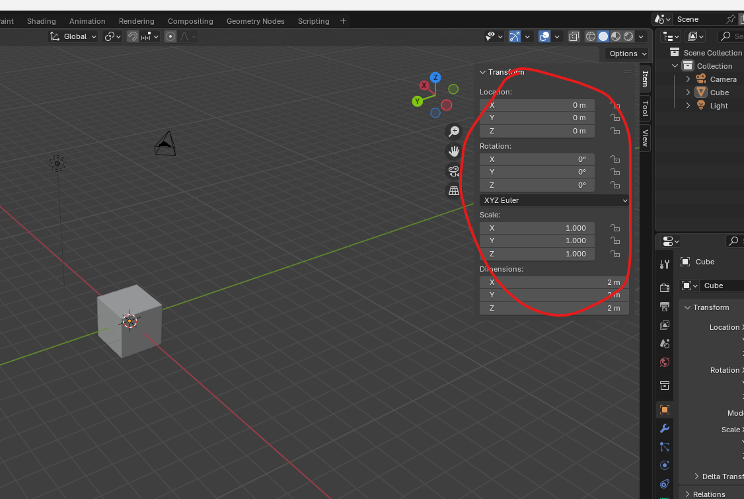

Or you can also open it by clicking on arrow pointing left as marked below

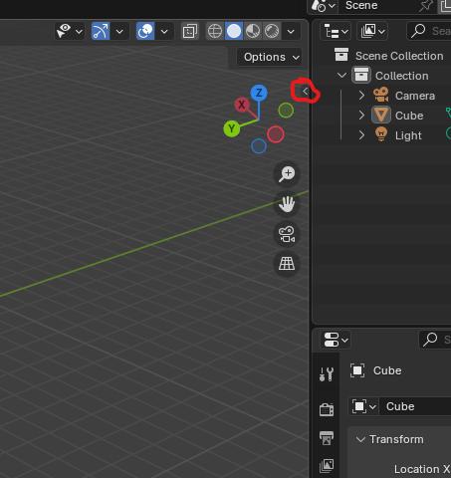

And you can close it by

The popup will be as marked above to pull up the sidebar or panel It can be easily accessed

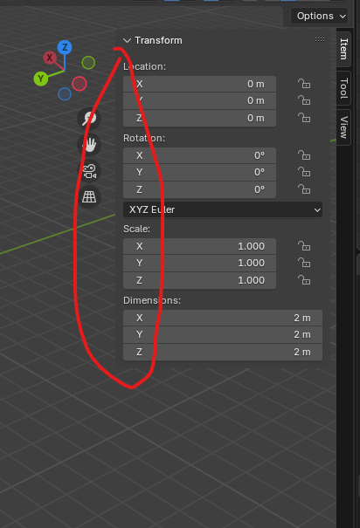

Now drag it from the edge and scale by dragging against the right side panels until it bome of 0 size in breadth

This will show you some information on the location, rotation and scale of the selected object under the item panel as msrked below

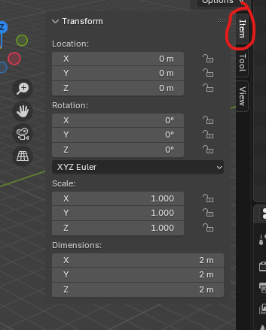

The tool tab’s active tool panel contains some options for your pointer( that is move ,scale, selection )

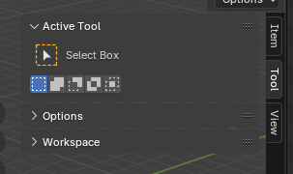

Which will also be shown on the top left of the screen as marked below for the selected pointer

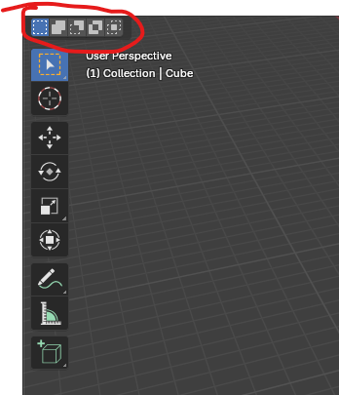

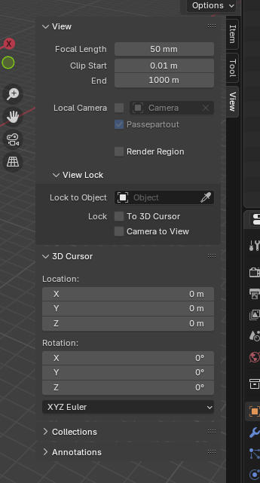

View tab has a few settings for the 3d viewport which we are not going to change at the moment

but we're going to. Go over it more later when it's more applicable.

These sidebar could contain tabs which exist because of the addons you enable.

The below shown tabs

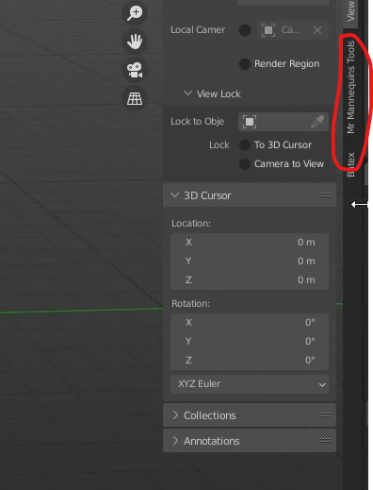

The above marked are the few here that Teacher use regularly, but we do not need them for this course.

Betex is a batch fbx exporter(I don’t know) and Mr. Manikins is this awesome plugin that loads in unreal engines default character models which is really just handy as a scale tool when you're building scenes for Unreal.  
You'll notice that the text tools add on. We downloaded and installed and the previous lesson is not here.

This is just it does not utilize the 3d viewport for any of its functionality so it lives inside another editor (maybe as a tab or a panel inside a tab (who knows) but by editor we mean modelling, UV, Sculpting )

If you press **t** key then it toggle on or off the toolbar on the right side as marked below

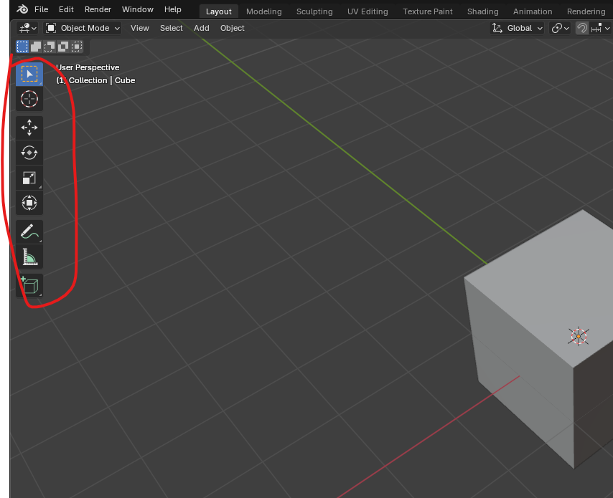

6:00

At this moment this contains some transform and selection tools but you will see as we progress

This menu is context sensitive and will change (maybe with workspace)

Navigating around the 3D space is critical to being able to use Blender because in order for us to see

Because in order for us to see what is on the other side of the cube, we need to be able rotate around it to rotate your view in blender

Simply hold the middle mouse wheel and drag your mouse around to rotate around the object. The object

If you ever confused about which way is up. There is gizmos as marked below

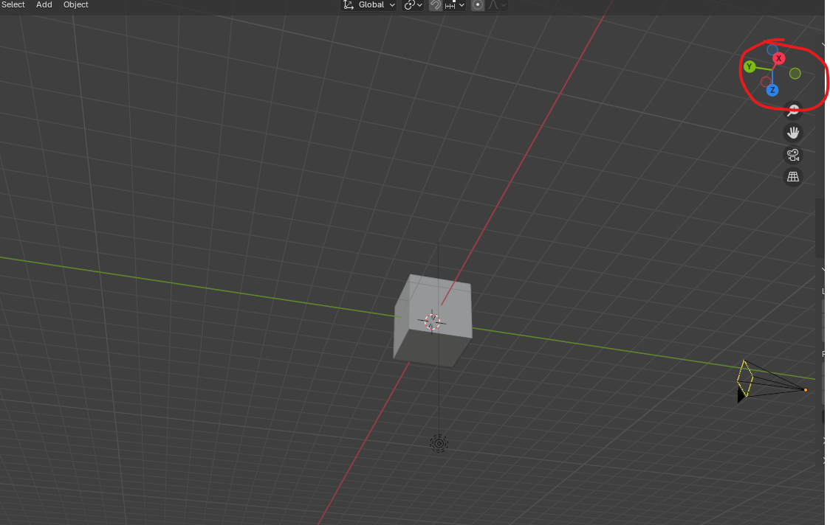

That’s just going to show you how your screen and how your view is currently oriented.

To pan your view around without changing the angle at which you(camera) are viewing an object, simply hold shift and middle drag button in the direction you wish to move

To zoom just use the scroll bar to zoom in and out

If you do not have mouse scroll then hold ctrl and then hold middle mouse button if you move inward then zoom in of the middle mouse go outward then zoom outward

But by scroll it zoom grid by grid but in ctrl + middle way it happens smoothly

All these operation can be done by clicking on there icons as marked below they are present below the moving gizmo(who knows name) which we discussed before that is on the right side of the 3d view part

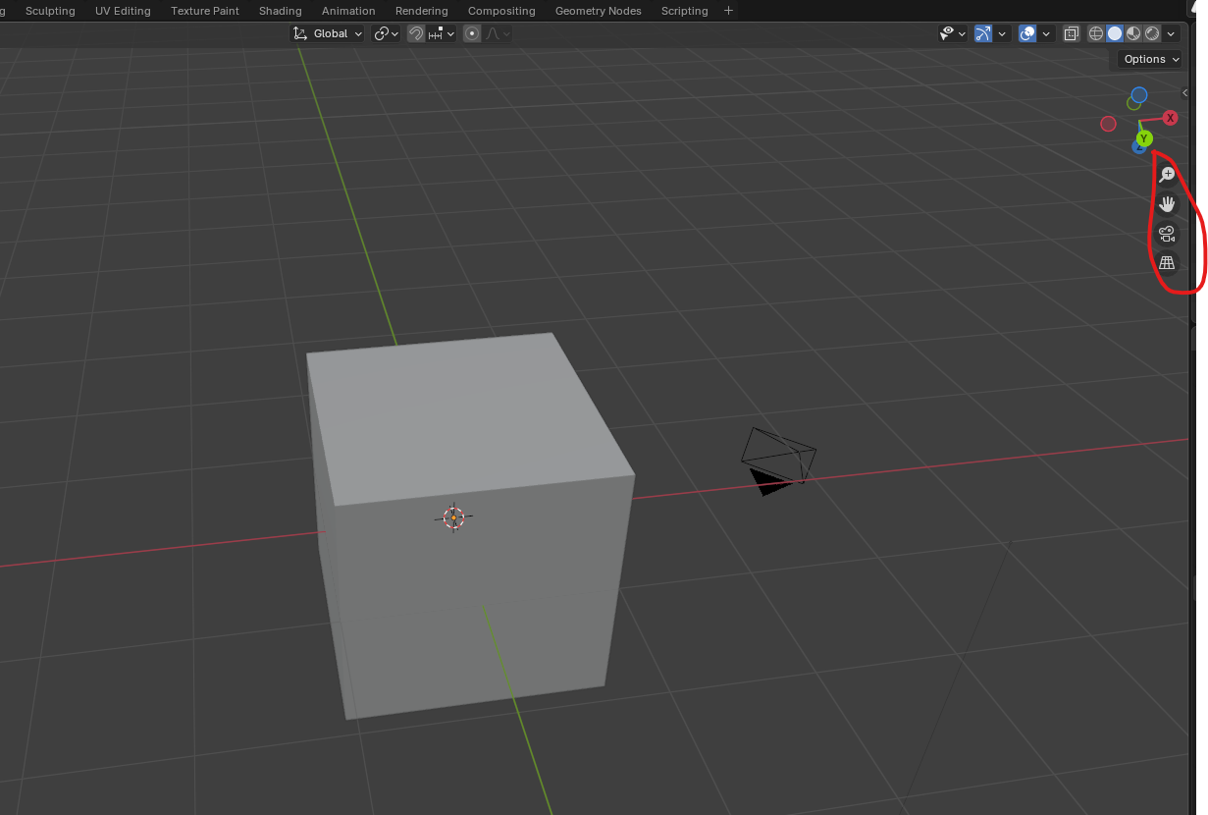

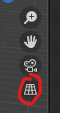

The last tool helps in switching between orthographic view and projection view(by the way both look almost same )

**Numpad 5** helps in switching between orthographic view and projection view

I will treat orthograph of the unity different from Blender

Orthographic view basically takes the view of our 3D model and flattens it out without perspective, orthographic view is most handy when you are modeling something and you want to view it exactly from the front side or back (it mean if we see an object while dragging by shift and middle click then in perspective you can see its other side but in orthographic nothing n such happens it like same even you by shift and middle click)

It is easy to quickly jump between orthographic views and blender

to see the front of your model press 1 on the numpad(reach orthographic)

you can see the view you are currently in by seeing on the marked below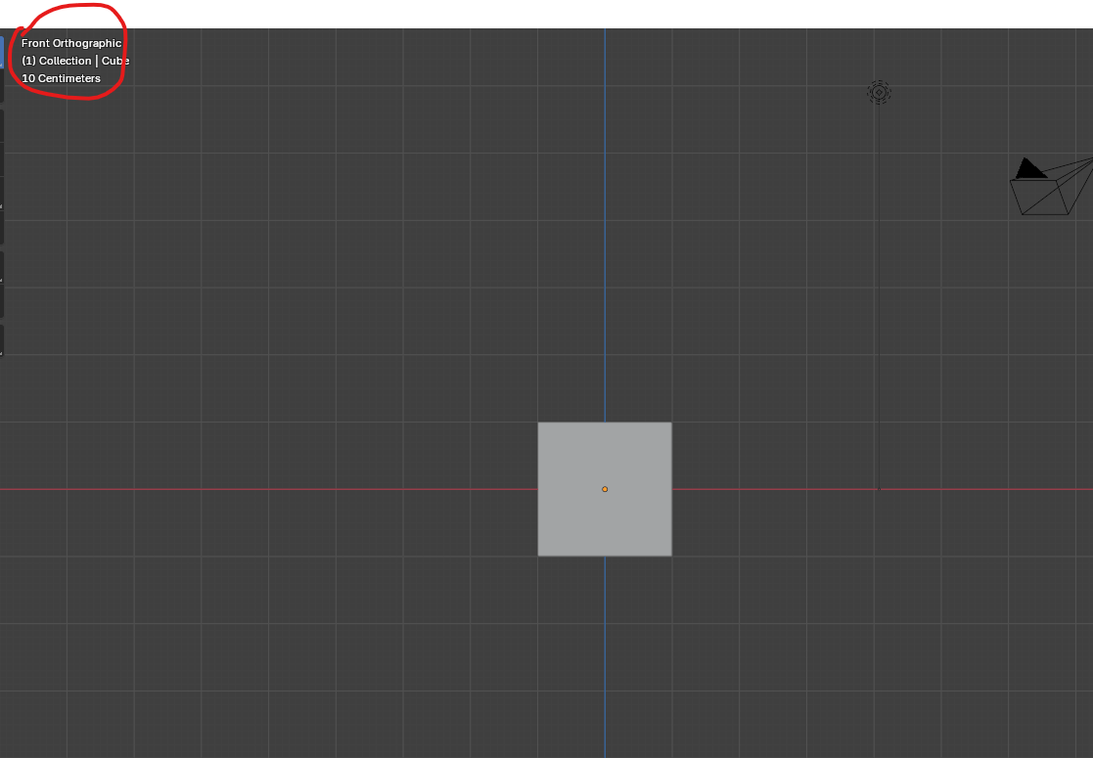(this is top left corner of the 3d viewport )

we are currently in front orthographic

now if you see around then it will show user perspective as marked below

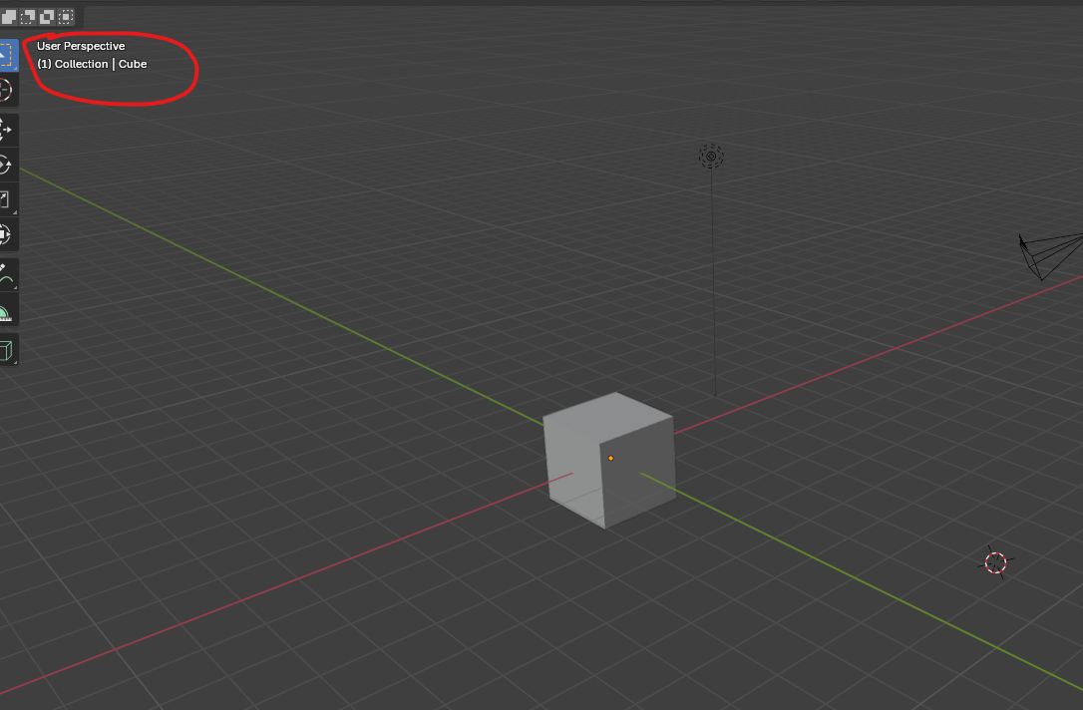

If you are ever unsure if you are in perspective or orthographic mode, you can always look at the top left

So our cube just appears as a flat square because we could only see the front side of it.

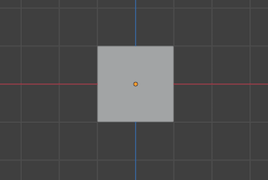

If you hold the middle mouse button and rotate around, Blender will automatically switch your view back into perspective mode.

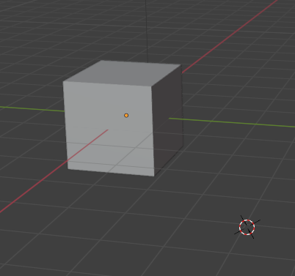

However, if you pan by holding shift middle mouse and dragging or zoom with the scroll wheel, you

can see that that orthographic mode is not broken.

If you want to see from the right side press **numpad 3**

To see form the top press **numpad 7**

To view from the left, bottom, back try to think of it as if you were viewing the opposite of the front, right or top because that is how the keyboard shortcuts are laid out.

So in order to view opposite side you just have to hit control and then press the numpad of the side whose opposite you want to view

So if one will snap you to the front topography then by pressing ctrl and then 1 will put you back orthographic and same for the other cases.

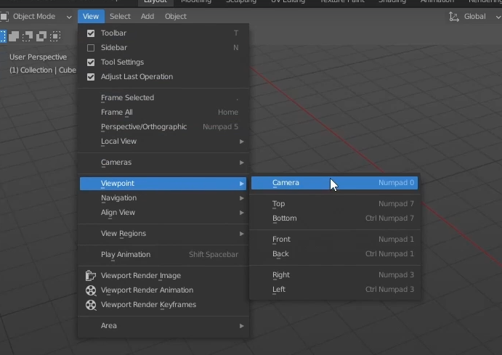

If you ever forget about you can go to view menu beside the mode selection option on top left and then go to viewpoint and then selecting any of these view will snap you to the view but it also shows you the shortcut keys for doing so from your keyboard right there

Additionally other way to navigate to the different by going to gizmo

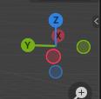

And if you click on any of the axis then its corresponding side will show

If you click on Y then back and -y front

Click on X for right and click on -x for left

Click on z for view from the top and -z for the bottom

The selected view will be shown in the front of the gizmos

Like x was selected then x will be center and at the front in gizmos

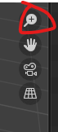

Click and hold and drag on the marked one to zoom in or zoom out as we do be ctrl and middle drag

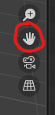

Click, hold and drag on the marked area to move as we do be shift and middle drag

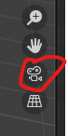

Click on the marked one to go to camera view that is you will be navigated to the view where you reach the position where your camera is and match its orientation you can also reach here by pressing 0 on the numpad

So now that you understand the 3D viewport, we can move on to the outline here, which is the panel marked below

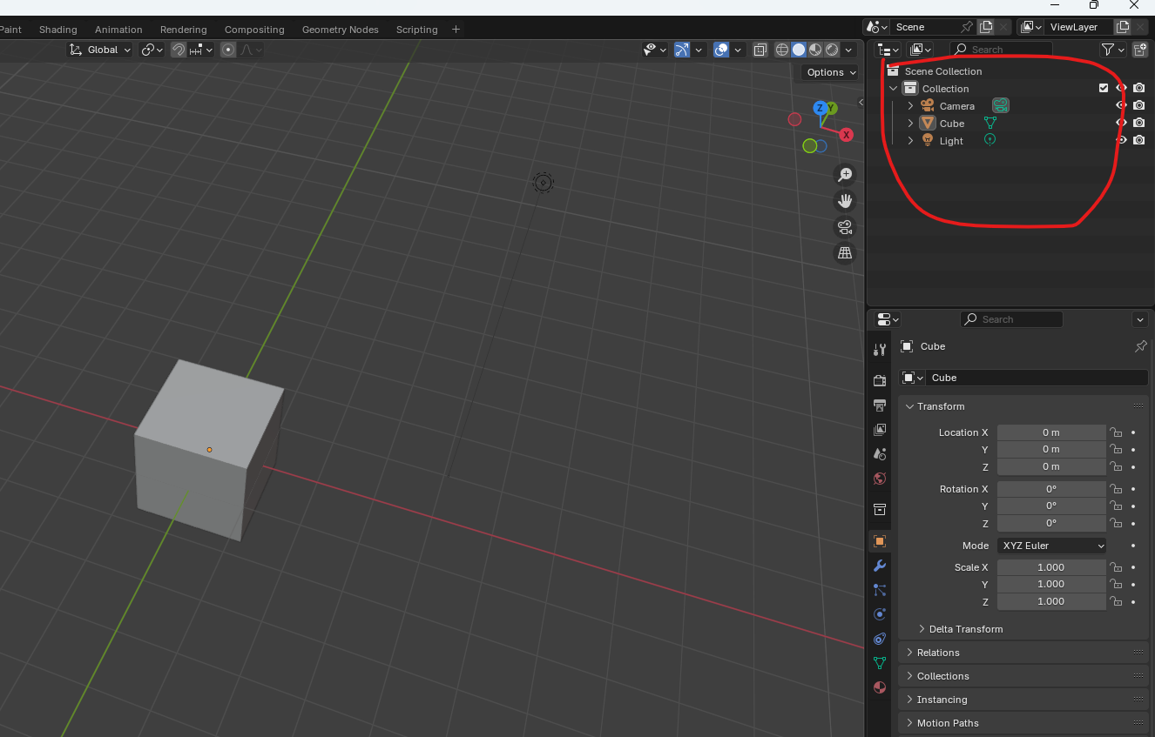

11:05

Outline are basically just a list or an outline of all the objects that are currently in our scene

The top most category on the outliner is scene collection as shown in marked above

That just means everything that’s in this entire blender file

We have one sub collection here called collection It is created by default

This just acts as a folder there .They are very handy for keeping your scenes organised and you might have hundred of objects if you were for an instance, creating an animated film.

Just like the files and folder right click on the empty area and then in submenu click on the new collection as shown below

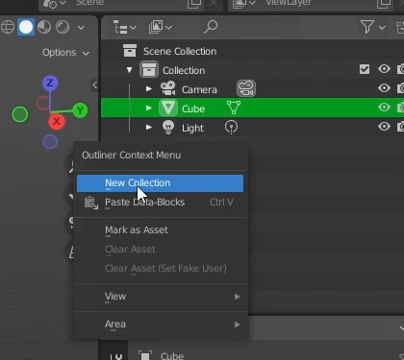

Now in outlines to rename any file or folder double click on the file or folder or after selecting press **f2**

To rename it to something meaningful

Organize your scene how you like it drag one object from one folder and drop it to another folder

You can collapse or expand the folder

Since it is basic course we might not work with any large scenes

You will notice that whenever I click on any object in the collection then it will be highlighted on the viewport as shown below

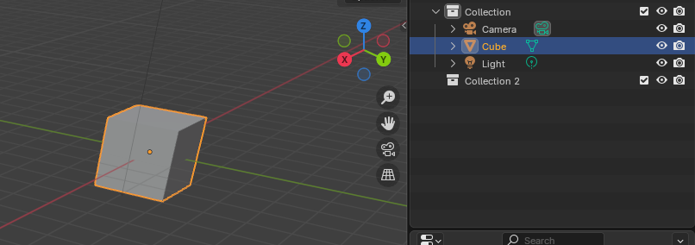

This functions exactly the same way as if we were to select from the viewport directly.

Selecting from outliner comes is handy in large scenes

Maybe you accidentally move your object way off into space and you couldn't find it.

You can, you know, find it in the outline here and move it back wherever you need it to be.

You can use the outliner to temporarily hide objects that might be in our way

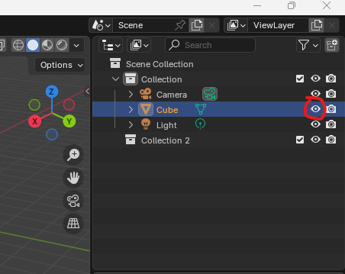

Select the object and then you can click on the marked above to hide the object

Now after that the eye object will look like marked below



The icon shoes that this particular object is hidden click on it again to unhide it

To hide an object select it and then press h button to hide that

And press alt + h to unhide all the objects present in the viewport

To unhide a particular object do it from outliner

Lets talk about Shortcuts Blender is a very shortcut heavy program. Blender has gotten a lot better about making its menu more easy to navigate

Teacher do think it is really worthwhile to learn them as it just speeds up your workflow so much when you really start modeling.

Now below the outliner panel is our properties panel

**Note:-**

FYI we are in Layout **workspace**

The properties panel is really important as it contains all the information for the selected object as well as some properties of the scene general ( which means I think is that its some side tab may contain properties related to the selected object or some tabs may contain properties of scene due to which scene will be effected by it )

The icon on the left are each a different tab as marked below

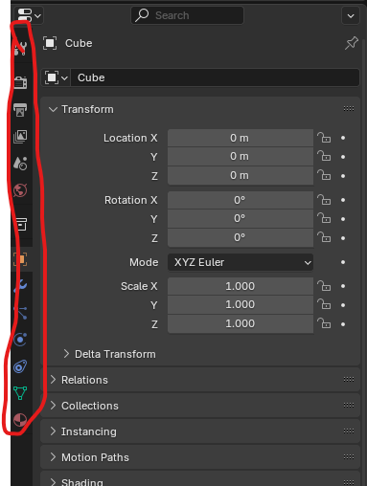

Now we are taking the name of the subpanel

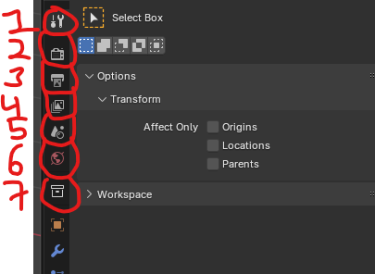

Active tool and Workshape setting (marked 1 )

Render properties ( marked 2 )

Output properties ( marked 3 )

View Layer properties ( marked 4 )

Scene properties ( marked 5 )

World properties ( marked 6 )

Collection properties ( marked 7 )

All of these are more general settings that affect things regarding the entire scene as well as how and where to render images to ( I don’t know )

We will cover more these later on into this course

Sor now we will be focusing on the bottom side tabs as they relate directly to the object that you have selected so now the cube is selected we have the marked below option

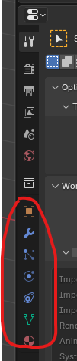

When I select other object then these tabs changed bit the top one that we discussed remains there

Suppose I select a cube then above is shown

But if I select a light then below tabs will be shown as marked below

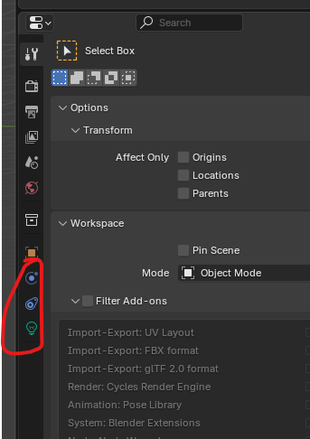

The tabs reflect the different properties of light.

16:00

Let look at the properties of cube just left click on it to select

Every object that you can add to the 3d viewport will have the object properties side tab as marked below

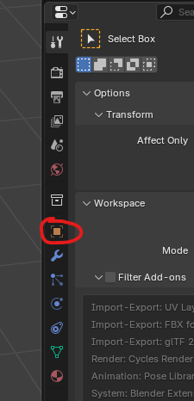

Since it will be present in all the object and it is do object specific tab you will not see it changing when selecting different object in 3d viewport

We won’t be using this one all that much as the only important for this basic course will be transform panel as marked below

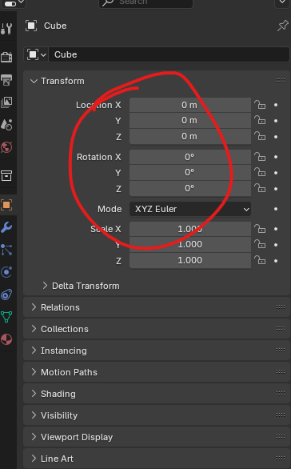

Which can be viewed easily in the sidebar in 3d viewport by pressing and going to item tab on the sidebar as shown below

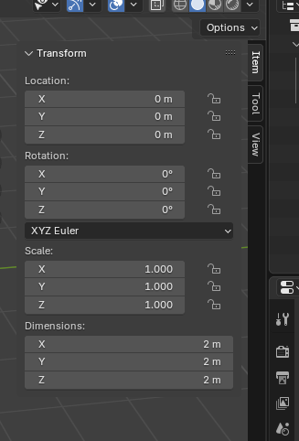

Next on the list is the modifier side tab as marked below

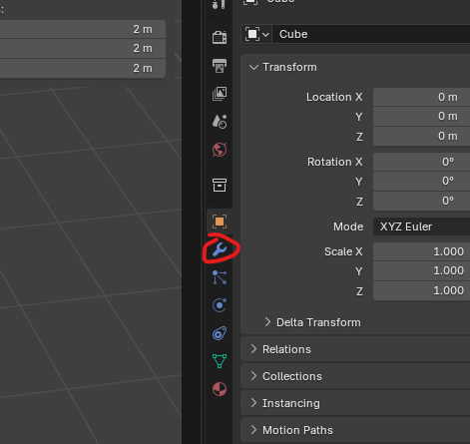

This is probably the tab you would be using most of the times in this course Right now there is nothing in it because of this cube has no modifier (I don’t know) We will come on this latter but if we click on the Add modifier as marked below

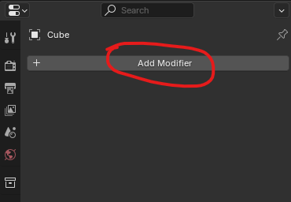

Now by clicking on it a dropdown will be shown

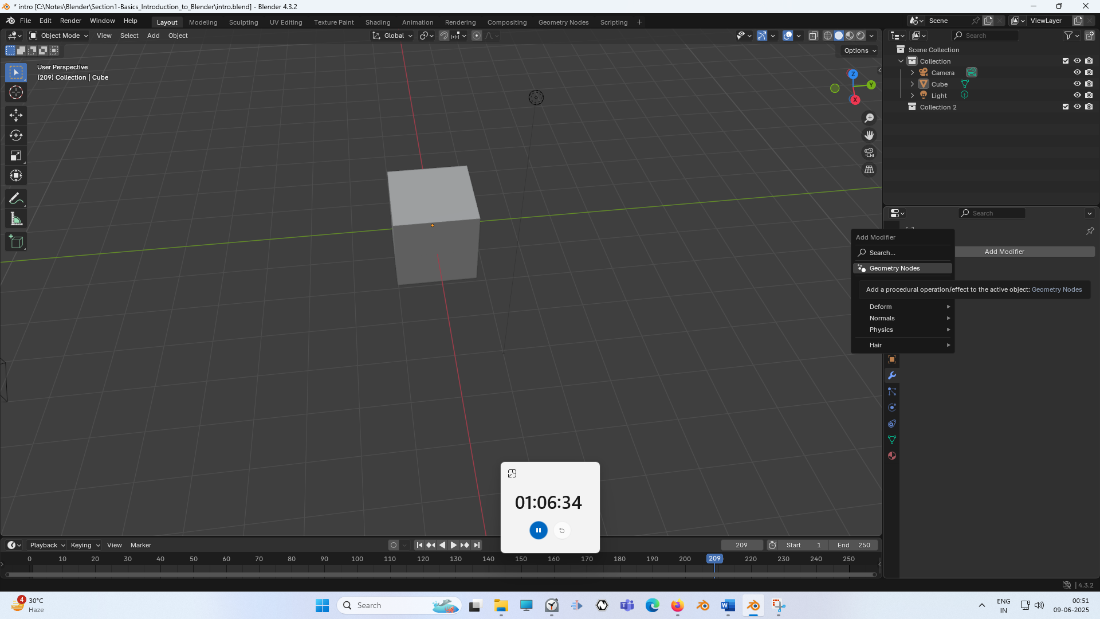

Now in drop does there is a whole list of things you can add to this cube to modify its shope and appearance. Next in the side tabs is particle properties as marked below

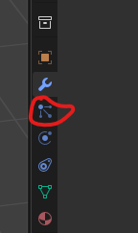

We may come back to this. It is slightly more advanced feature, but we will be probably touch on it briefly towards the end of the course

Same with the physic properties as marked below

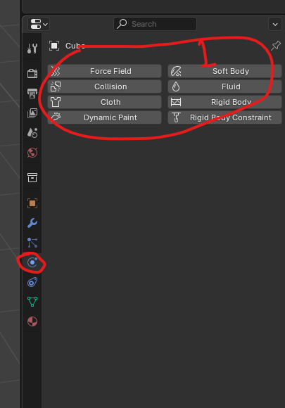

Now in marked 1 inside physics properties sidetab. These are some really cool physics properties you can use to animate a mesh in such a way that it would automatically behave like glass or water

But again, it's a cool feature, but it's slightly more advanced than we will really be covering.

We won’t be covering object constraints and data properties as marked below

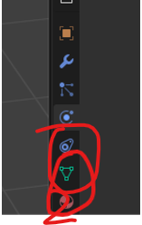

We will touch on it Probably when we talk about UV maps which is present in data properties as marked below

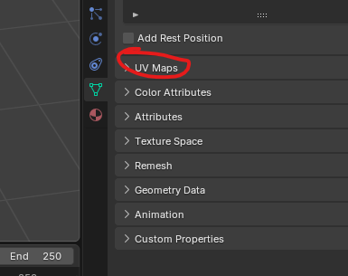

Now comes material properties as marked below

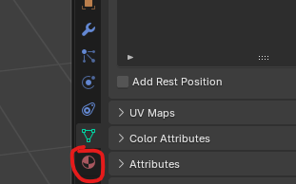

This will probably be your second most used property side tab. This controls how the surface of your 3D objects appear when they're rendered. So if you wanted to change the color of an object, for example, they would be controlled here through the material tab.

The last is Texture Tab and we'll be getting back to this one when we talk about texture painting(who knows).

I could not find Texture tab in properties because

If you’re not seeing the **Texture** tab when you select a cube in Blender, it’s probably because, in **Blender 2.8 and newer**, textures are no longer handled through a separate "Texture" tab. Instead, texture-related settings are integrated into the **Material** properties and **Shading workspace**.

The last panel is the animation timeline as marked below

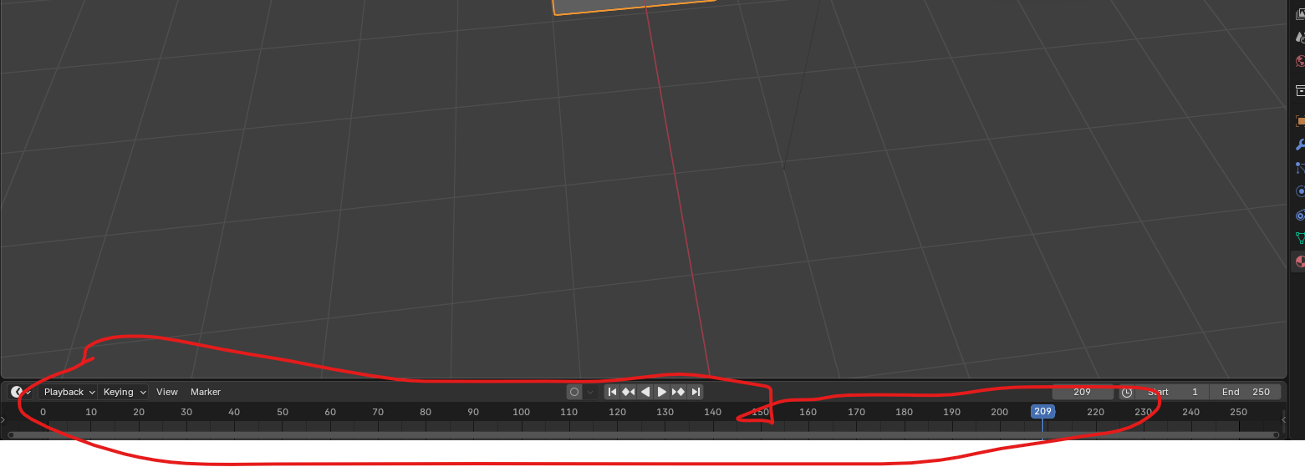

This timeline shows any animation that you may have in your scene.

We don’t have animation on our cube but if we did we would be able to see them by pressing play button as marked 1 below and they would play here on the object itself.

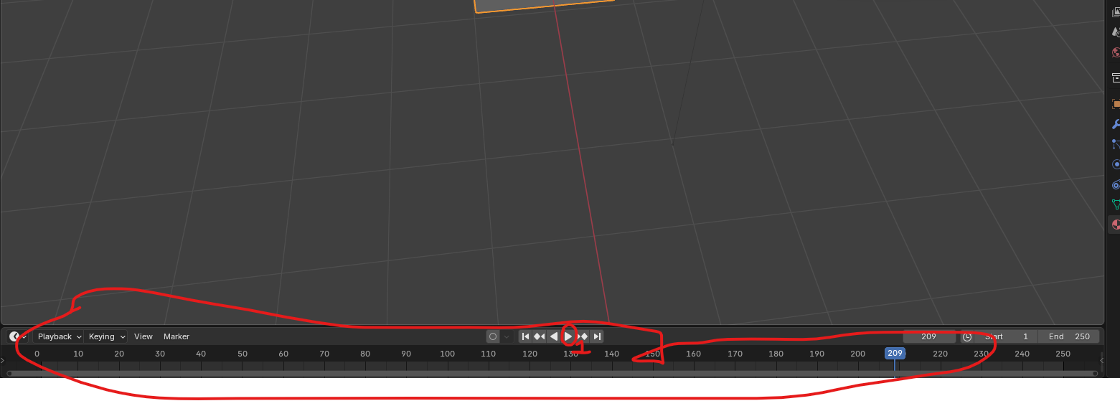

18:35

We also have rewind(marked1), pause(when played replace play button (I think so)) and forward features ( marked 3 ) and for next keyframes ( marked 2 ) and also reverse of it

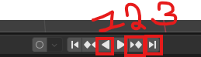

The timeline down here represents the animation in frames.

Blender defaults to 24 frames per second which is standard, I believe, for animated films. The settings can be changed in the properties panel under output properties format as marked below

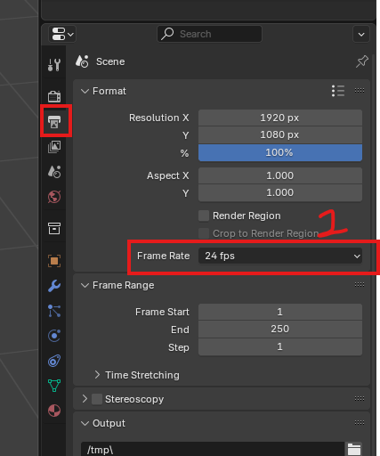

Now we go to frame rate as marked 1 Now you can click on the drop down in it then in drop down you can set a predefined frame rate. Or also set custom

As shown below

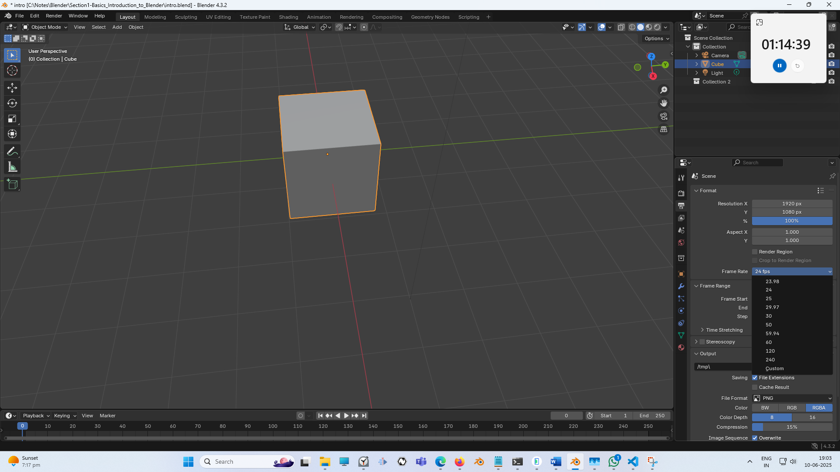

If you are working for an animation of a game , you would probably want it to change it to at 30

That’s pretty standard for console games but the next gen games, the ps5 game snow run at 60 you could change it to that as well But for now, we're just going to leave it at 24.So to convert the timeline to seconds, it's just the frame number divided by your frame rate in the timeline. In your case 24 so 120/24 => 5 seconds of animation.

We're going to cover some basic object animation in this course, but anything like animating characters is just a bit beyond the scope of a basics course.

Now all these panel are completely configurable. You can resize any of these panels by clicking on dragging on the space between them. You can also bring in a new panel by moving the cursor over to the corner of any existing panel until you get the crosshair as shown below in place of the pointer

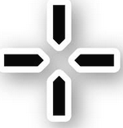

If you drag pull it out, you now split this window into two separate panel

For example If we want to split 3d viewport into two then it looks like below

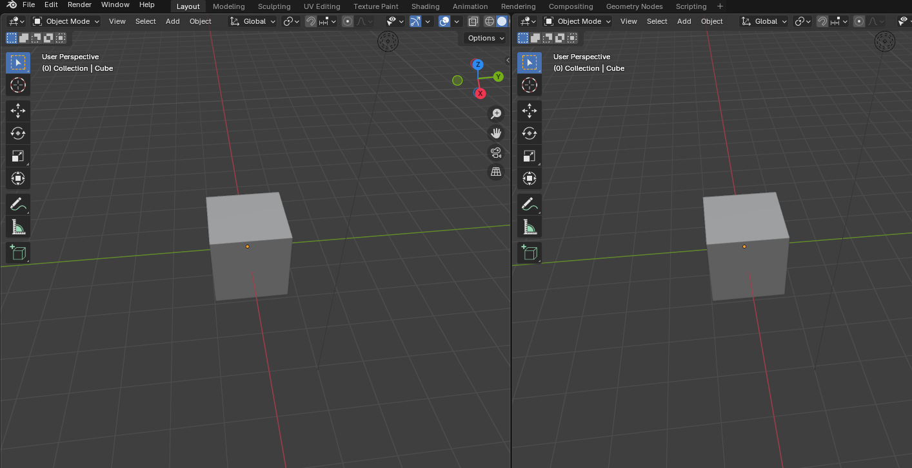

it's now split this panel into two separate panels. So right now it just created another 3D viewport

**Note:-**

I think editor is a very general term and it is used when are creating or editing an already existing thing by this logic every panel can be an editor. But you can change what editor is displayed in any panel by clicking the dropdown icon at the top where it says editor type in tooltip.

Now if you click on any option in the submenu as shown below it will open that panel in place of currently opend panel in that window

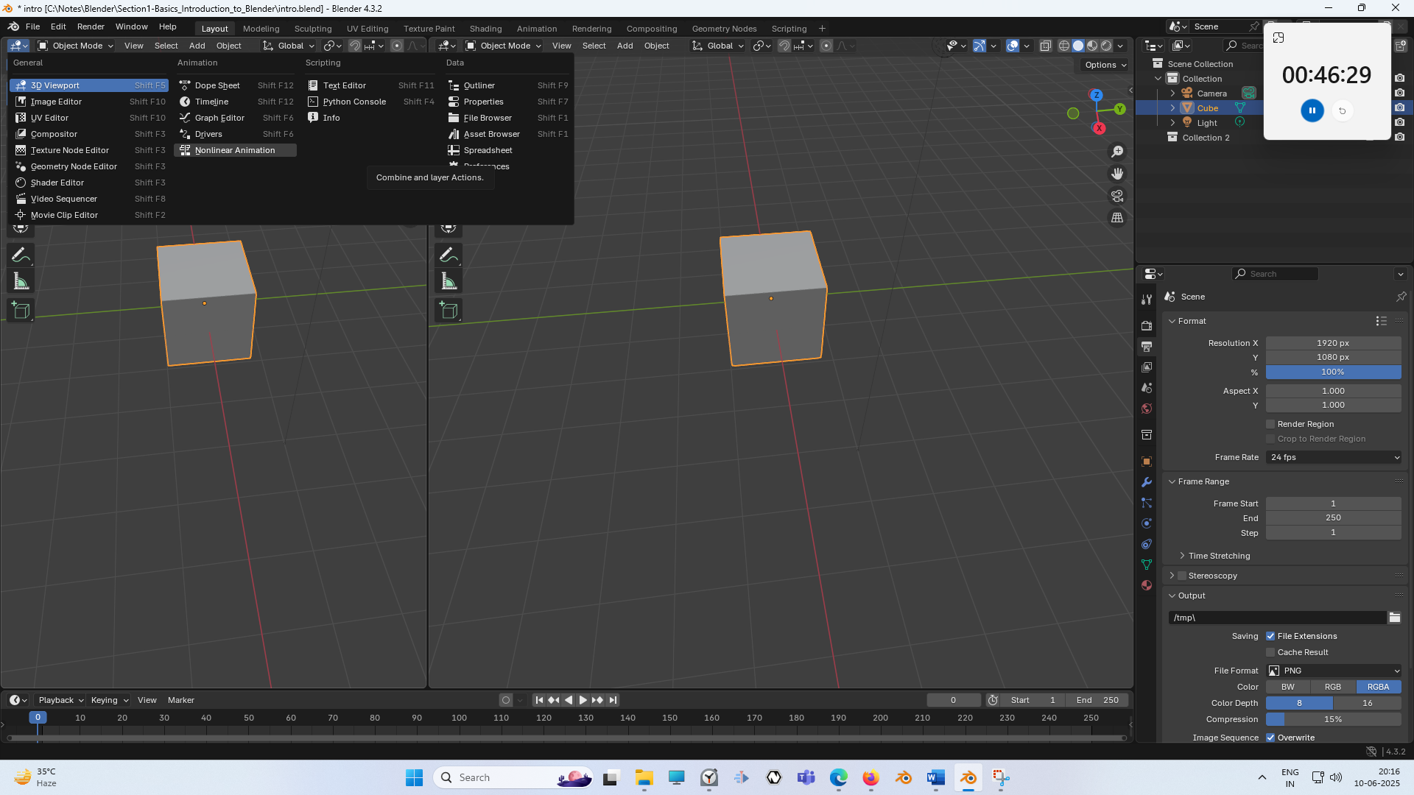

For example we can change the 3d viewport to shader editor Now it will look like below

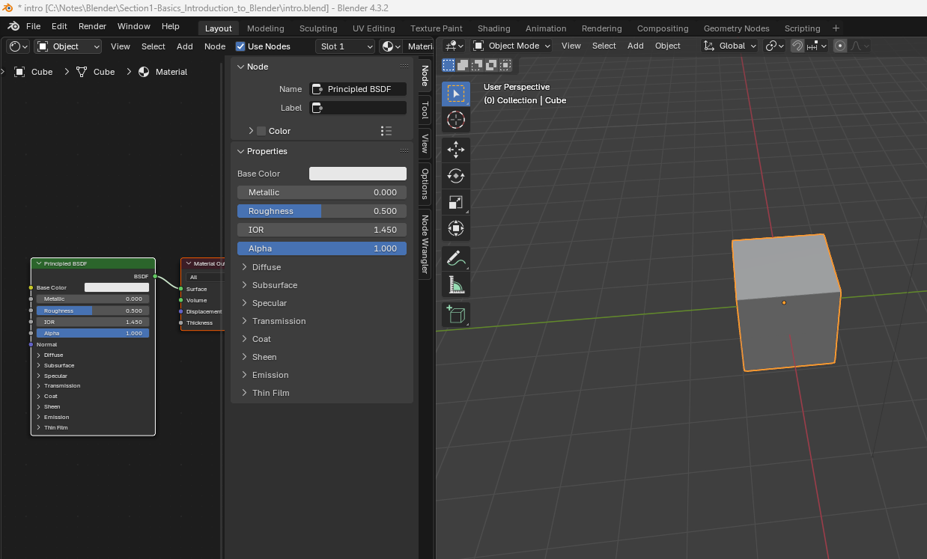

And now this shader editor would give us access to Blender’s visually scripting system for creating materials

Press Shift + f3 to convert the active panel to the shader editor

Press Shift + f5 to convert the active panel to the 3D viewport

You can press the Shift + f3 again and again to toggle between panels whose shortcut key is Shift + f3 you do similarly for the other shortcut key

If you don’t need a particular active panel you pulled out place your cursor on the corner between windows as marked below and here the pointer will like the crosshair, hold the left mouse button,

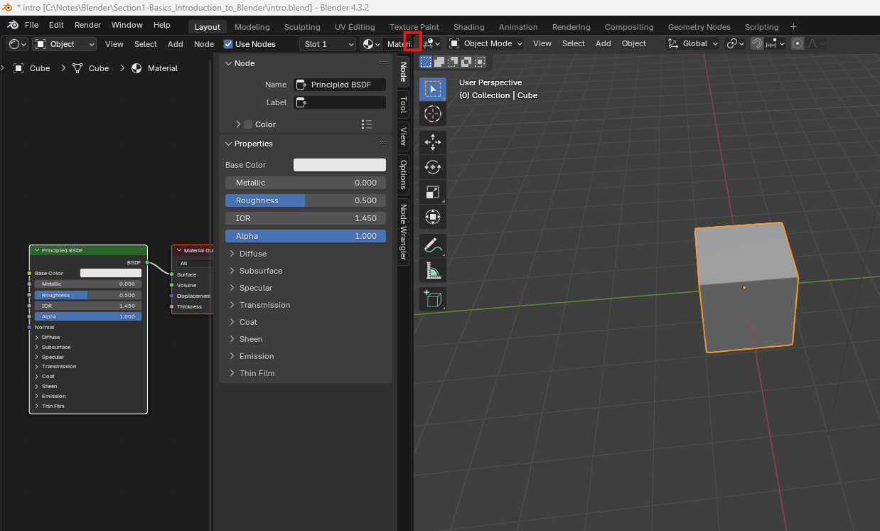

And then the mouse pointer will be convertedtothis **<** shape and now move over to the panel which you want to be removed But it does not work like this in modern version

In newer version to go to the corner of the panel which you want to be stayed and now hold left click and then move the pointer to the panel that you want to be removed the pointer will be converted to the **+** **( pointed from all sides )** sign and then that panel will become slightly darker and be removed.

So all these different panels we've just gone over are part of the layout workspace as marked below

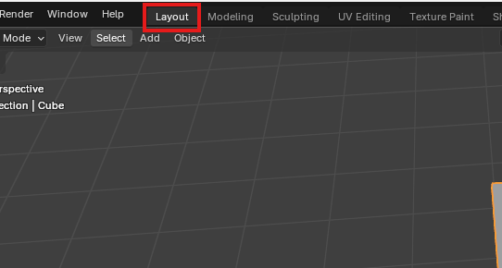

Workshape in Blender is just a preset configuration of panels designed to speed up your workflow

For example

You can either pull out a panel and then set it to UV editor as shown below

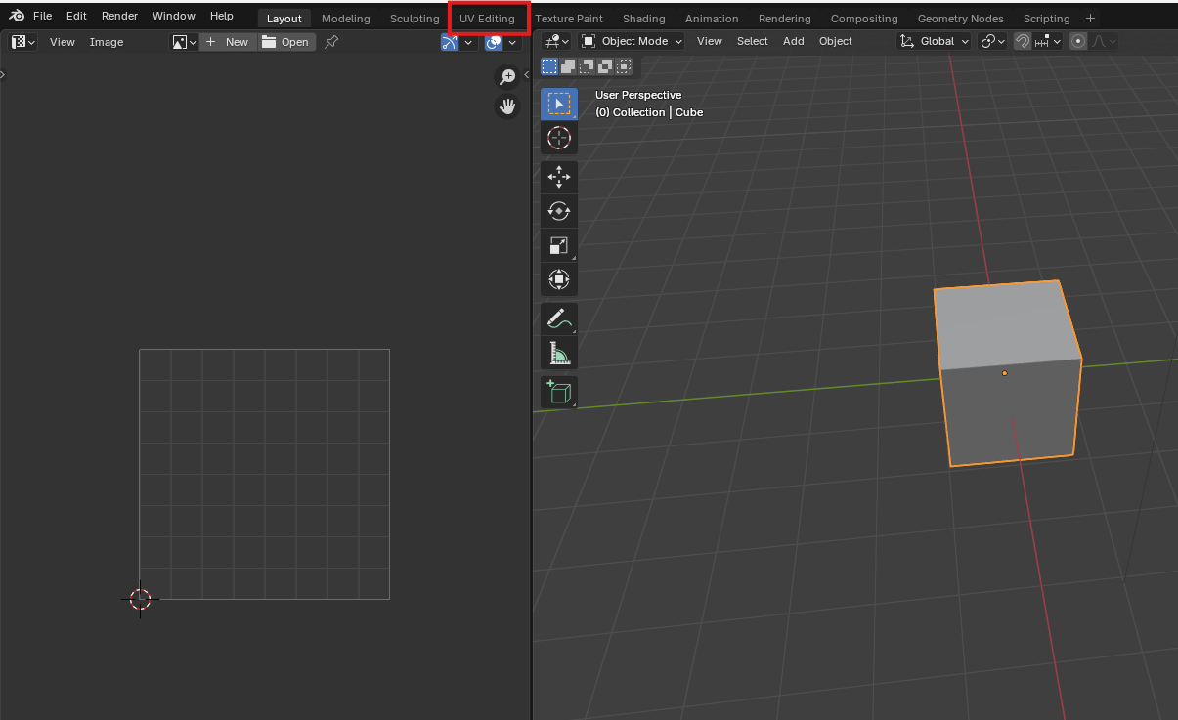

or you can just go to marked above to go to UV Editing workspace. Now UV Editing it is shown below

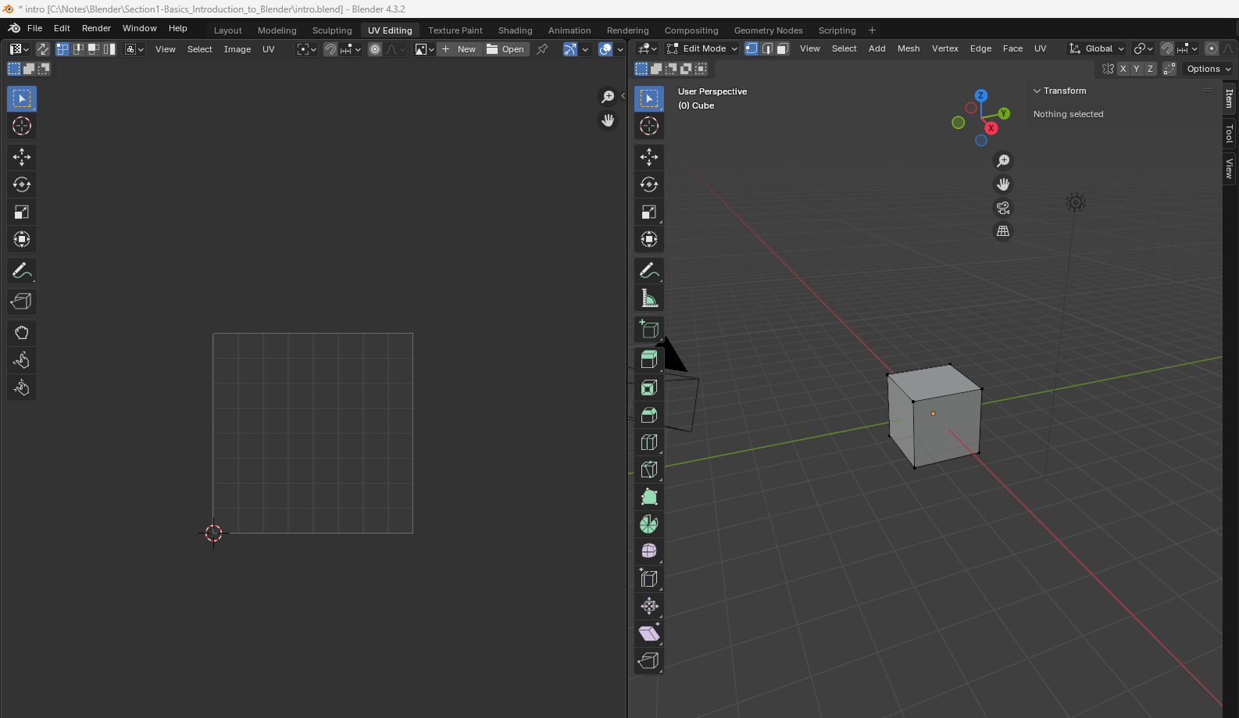

All this does is it removed the animation timeline and it spilt the panel ( where we see the 3d viewport in the layout workspace ) into two where we have 3d viewport one side and on the other side we have UV editing panel. We'll go over what you UI's are later.

22:25

Teacehr don’t expect us to know that what is it .Just know that this panel configuration is has been pre optimised for UV editing (maybe it means that this workspace is such that you can do UV editing easily here The same goes for all these workspaces. As marked below



Now we go back to Layout

We will be using a few of them during this course, but any of them is configurable and renamable(they can be changes and renamed)

You can make a custom workspace by clicking on the + sign as marked 1 above

Now in submenu you can choose any template as shown below

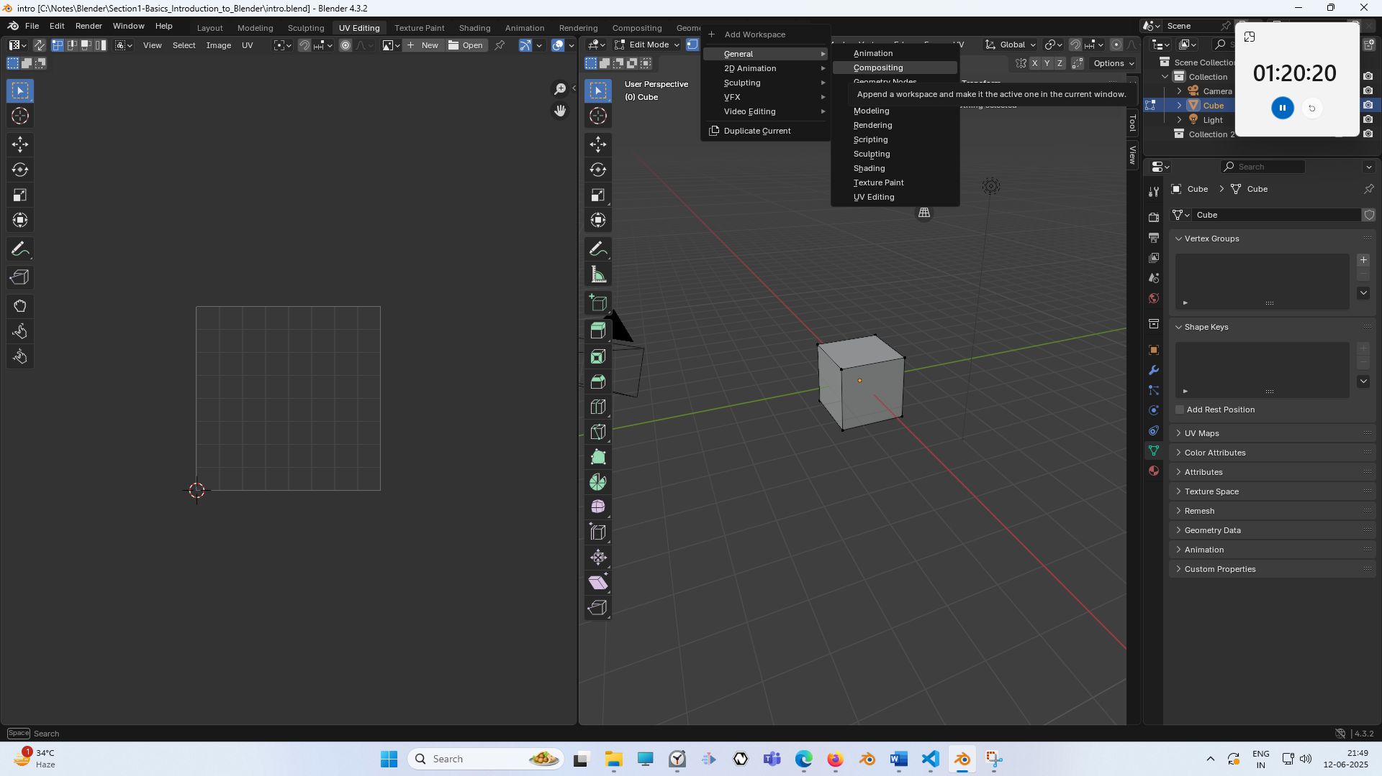

In general submenu menu you will see option of workspace which you can currently see in the marked below



You can create new workspace based on whatever you select in general will be the new workdpace with different name but have the same configuration of the workspace you selected

We choose modelling in general so that now it look like below

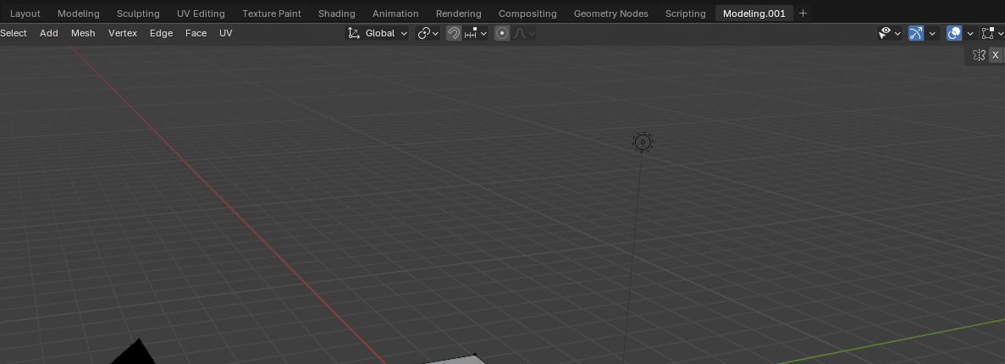

Now you can add whatever editor you want here by the way teacher has taught us as shown below

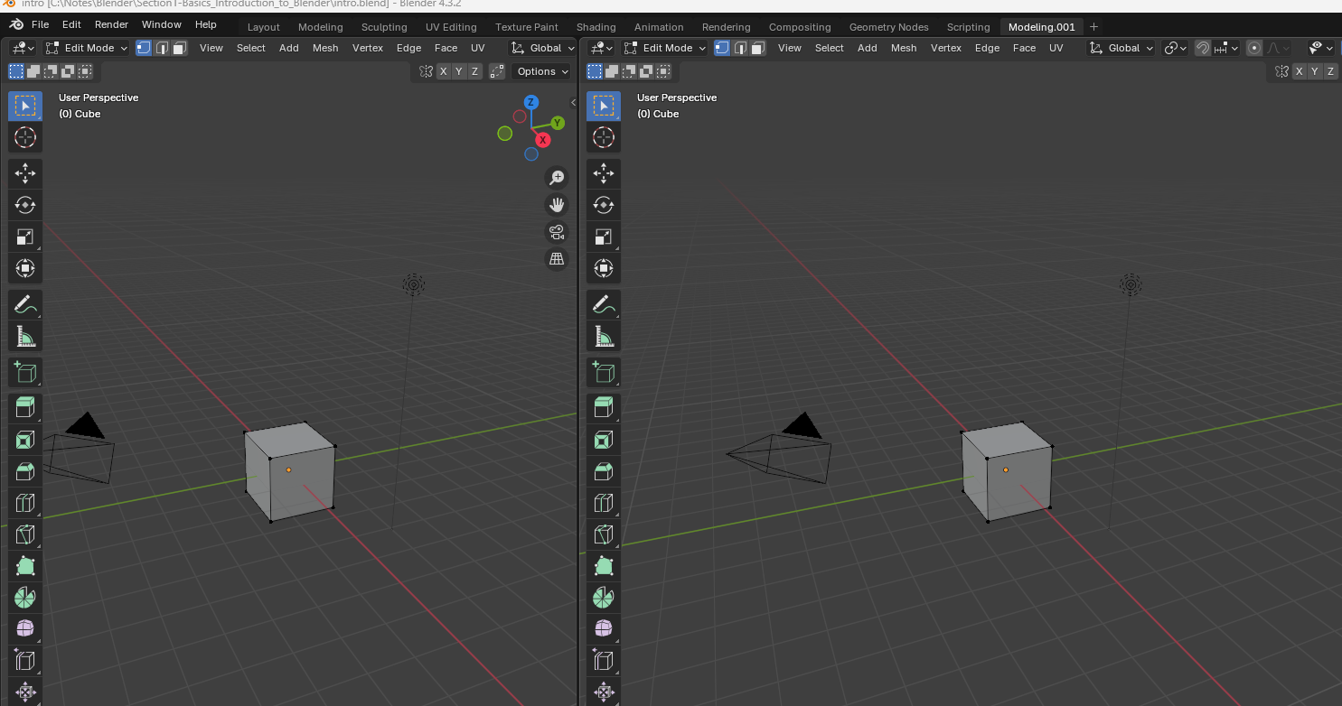

Now these custom workspaces are on a per file basis, meaning that if you save this file and reopen it, this custom workspace will be as you left it. But if you create a new file, this workspace will not be there.

Speaking of which, if you wanted to save your blender scene, it's pretty standard. But you're just going to come up to this top where it says File Click Save or Save As whichever.

Now when you save the file and then you reach that location where you saved it ad <Filename>.blend

.blend is a special extension which can be opened by blender(who knows)

So if you need to get a 3D model that you've made in Blender to another program like a game engine,, there are ways to do that. It's just not going to be using this blend file here. We will cover that more later on in this course.

So in the next lesson we will learn how to add objects into a scene and how to move, rotate and scale these objects.